**EXPRIMENT NO-23**

**CSA1142-OBJECT ORIENTED ANALYSIS AND DESIGN**

**ONLINE SHOPPING SYSTEM**

**USE CASE**

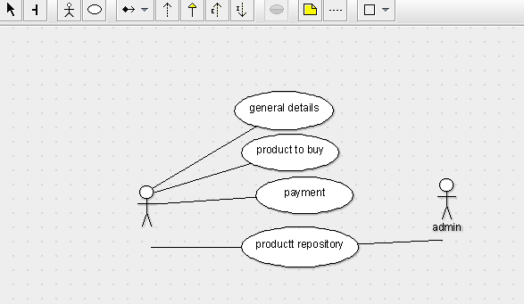

STATE DIAGRAM

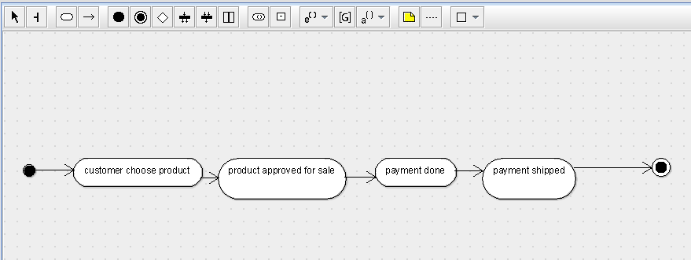

SEQUENCE DIAGRAM

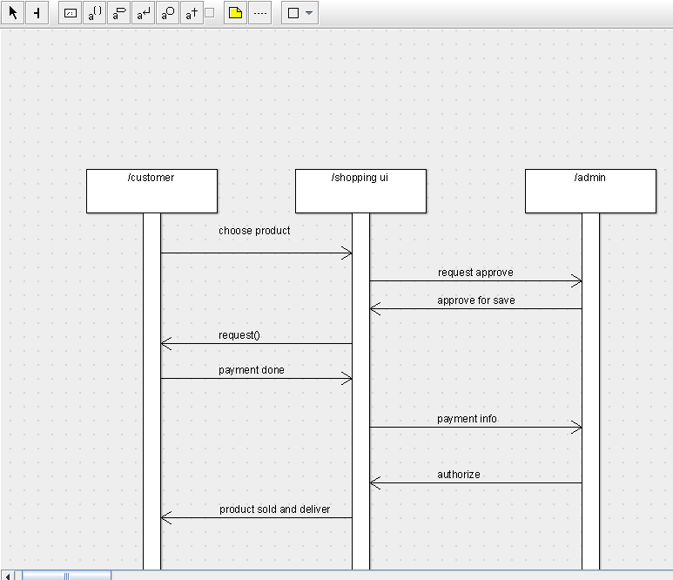

DEPLOYMENT DIAGRAM

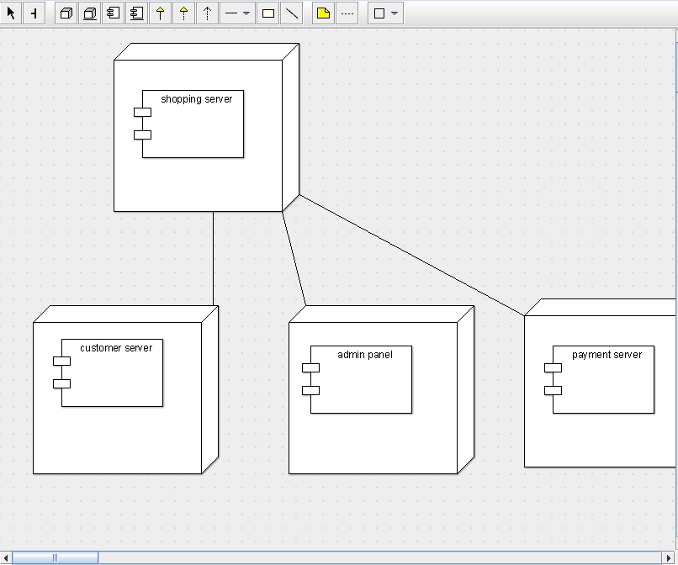

COMPONENT DIAGRAM

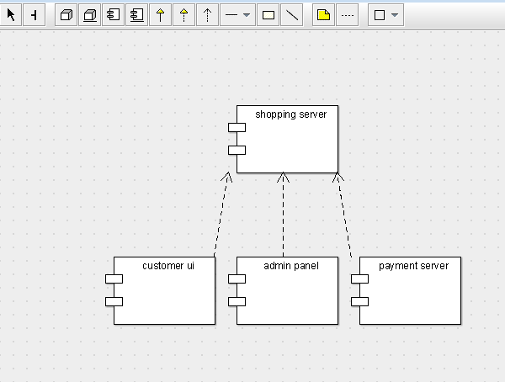

COLLABORATION DIAGRAM

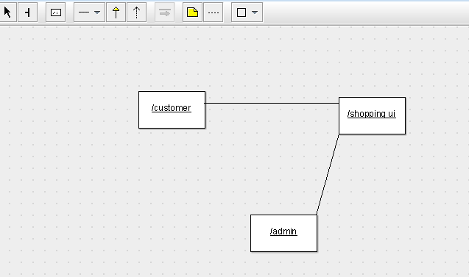

CLASS DIAGRAM

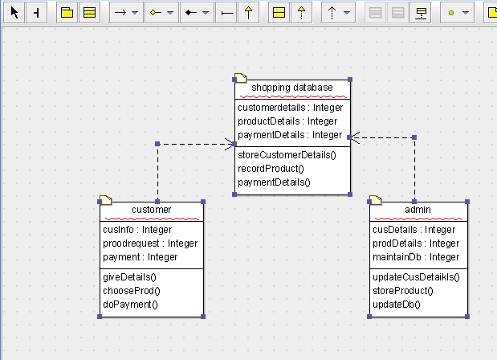

ACTIVITY DIAGRAM

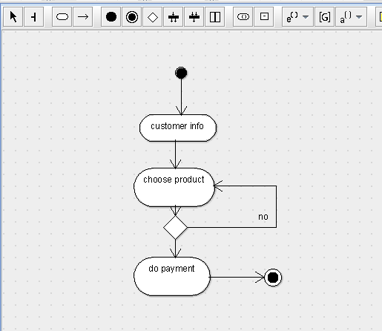

SKELETON CODE;

public class shopping database {

  public Integer customerdetails;

  public Integer productDetails;

  public Integer paymentDetails;

  public void storeCustomerDetails() {

  }

  public void recordProduct() {

  }

  public void paymentDetails() {

  }

}

public class admin {

  public Integer cusDetails;

  public Integer prodDetails;

  public Integer maintainDb;

  public void updateCusDetaikls() {

  }

  public void storeProduct() {

  }

  public void updateDb() {

  }

}

public class customer {

  public Integer cusInfo;

  public Integer proodrequest;

  public Integer payment;

  public void giveDetails() {

  }

  public void chooseProd() {

  }

  public void doPayment() {

  }

}